Connect between signal and slot

QtCore.QObject.connect(widget, QtCore.SIGNAL(‘signalname’), slot_function)

Call slot function

widget.signal.connect(slot_function)

for example

QtCore.QObject.connect(button, QtCore.SIGNAL(“clicked()”), slot_function)

button.clicked.connect(slot_function)

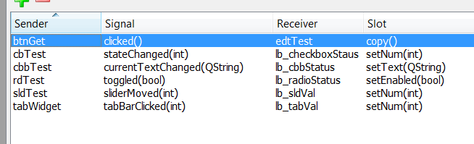

Convert file

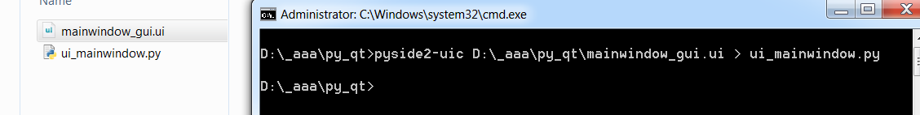

Convert resource file to py

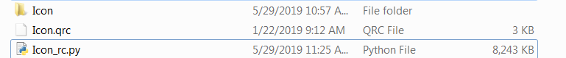

pyside2-rcc D:\_aaa\py_qt\Icon.qrc -o Icon_rc.py

convert prgram py to exe

pip3 install pyinstaller